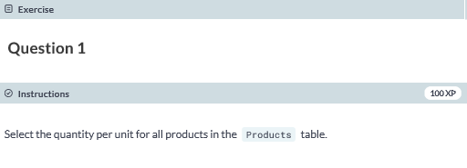

**SELECT QuantityPerUnit FROM dbo.Products;**

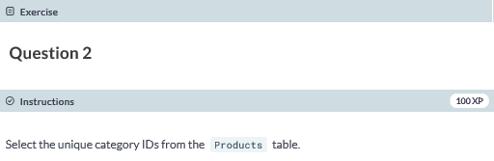

**SELECT DISTINCT CategoryID FROM dbo.Products**

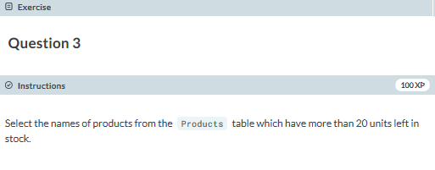

**SELECT ProductName FROM dbo.Products WHERE UnitsInStock > 20;**

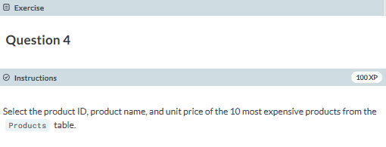

**SELECT ProductID, ProductName, UnitPrice FROM dbo.Products WHERE UnitPrice IN (SELECT TOP 10 UnitPrice FROM dbo.Products ORDER BY UnitPrice DESC);**

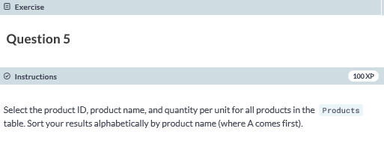

**SELECT ProductID, ProductName, QuantityPerUnit FROM dbo.Products ORDER BY ProductName;**

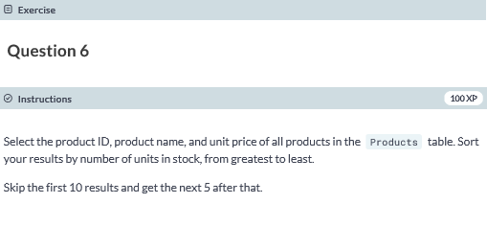

**SELECT ProductID, ProductName, UnitPrice FROM dbo.Products ORDER BY UnitsInStock DESC OFFSET 10 ROWS FETCH NEXT 5 ROWS ONLY;**

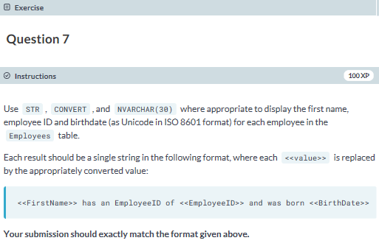

**SELECT FirstName +' has an EmployeeID of '+CAST(EmployeeID AS VarChar(3))+' and was born '+CONVERT(NVARCHAR(30), BirthDate, 126) FROM dbo.Employees;**

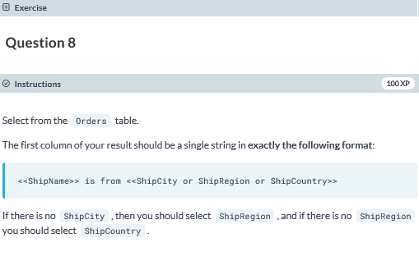

**SELECT ShipName + ' is from ' + COALESCE(ShipCity, ShipRegion,ShipCountry) FROM dbo.Orders;**

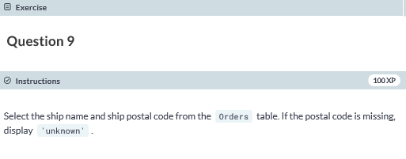

**SELECT ShipName, ISNULL(ShipPostalCode, 'unknown') FROM dbo.Orders;**

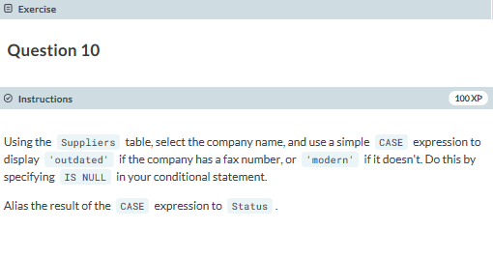

**SELECT CompanyName,**

**CASE**

**WHEN Fax IS NULL THEN 'modern'**

**ELSE 'outdated'**

**END AS Status**

**FROM Suppliers;**